**DSA ASSIGNMENT - JUNE 18**

Name - Vijay Kumar Saini

Roll.No - 23/11/EC/027

LeetCode Id - vijay_kumar_saini

GeekforGeeks - sainivij3yo0

Github Repo Link: <https://github.com/vijaysaini2613/jnu-ass>

## DSA SECTION

1. Two Sum

○ Platform: LeetCode

○ Link: <https://leetcode.com/problems/two-sum/>

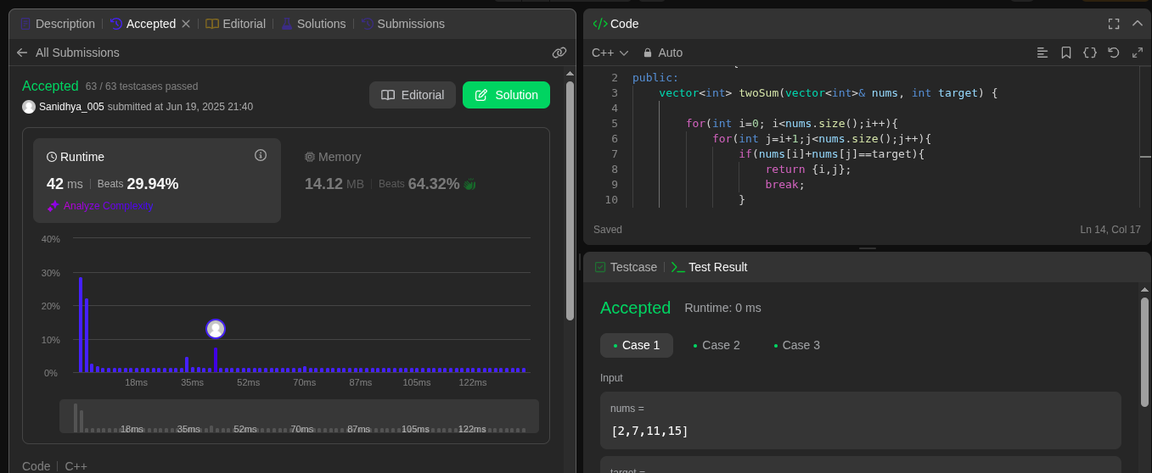

2. Alone in Couple

○ Platform: GeeksforGeeks

○ Link: <https://www.geeksforgeeks.org/problems/alone-in-couple5507/0>

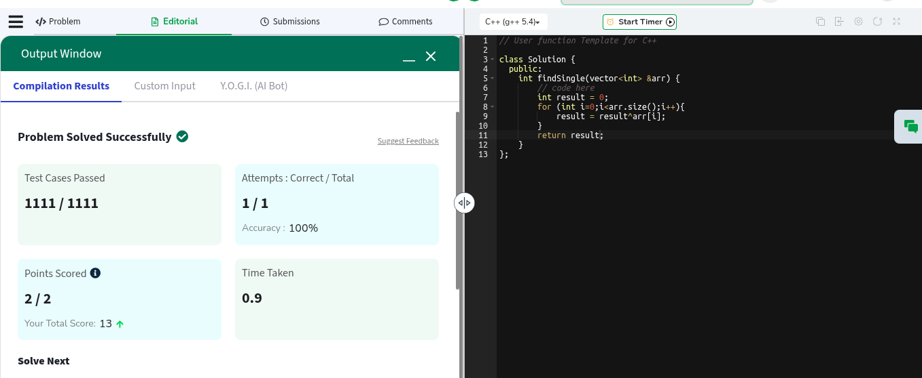

3. Best Time to Buy and Sell Stock

○ Platform: LeetCode

○ Link: <https://leetcode.com/problems/best-time-to-buy-and-sell-stock/>

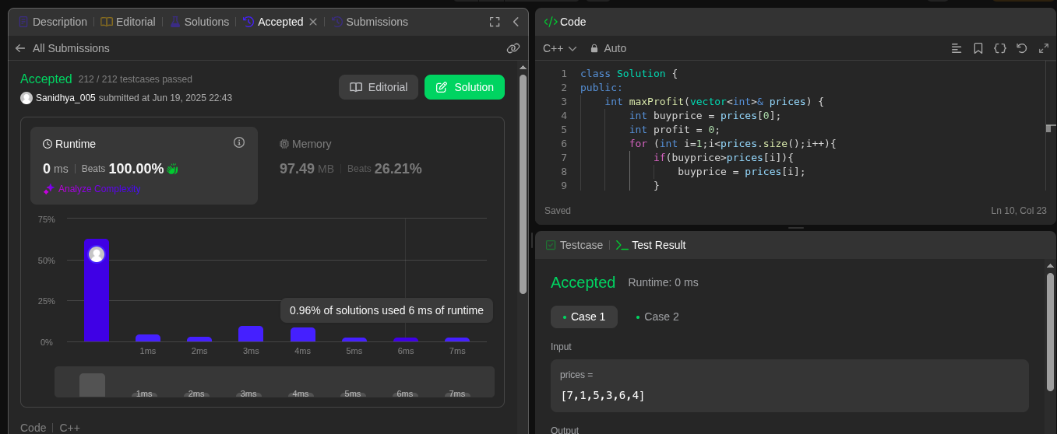

4. Sort Colors

○ Platform: LeetCode

○ Link: <https://leetcode.com/problems/sort-colors/>

